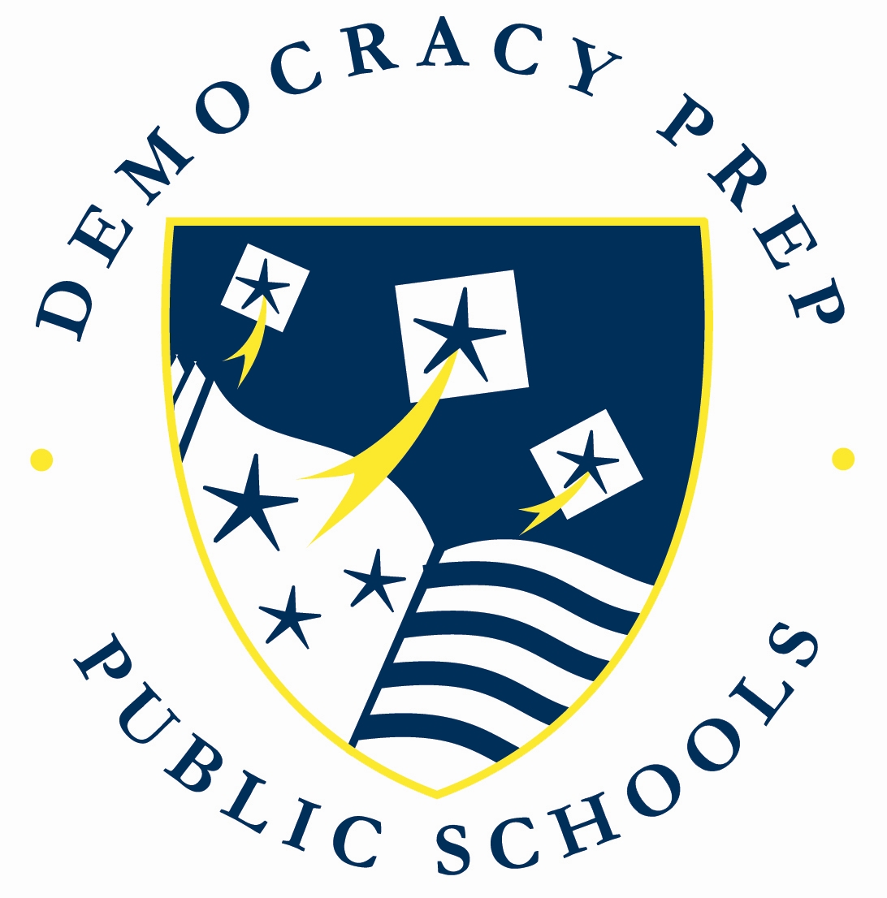

ACCEPTABLE INTERNET USE AGREEMENT

Internet access, student email accounts, and other digital resources are provided by Democracy Prep Public Schools to support instruction and appropriate student learning. While the Internet can be a powerful educational tool, it is also an unregulated space that contains materials unsuited to the school setting. For this reason, we will make every reasonable effort to ensure that this resource is used responsibly, and will further require that every student and parent sign the accompanying Acceptable Internet Use Agreement before full Internet and student email access is granted.

Student and Parent Agreement

Student use of the Internet and email at Democracy Prep is a privilege. If used properly, these resources can greatly enhance a student’s learning experience. However, anyone who uses the Internet improperly or for purposes inconsistent with the educational program at Democracy Prep will lose all network privileges. Democracy Prep uses industry-leading technology to monitor Internet activity and prevent student use of inappropriate materials. However, Democracy Prep cannot guarantee the appropriateness of all material accessed by the students on the Internet. Students at Democracy Prep agree not to do any of the following unacceptable uses of the Internet. Violation of this agreement may result in loss of a student’s online privileges and other disciplinary action.

- Sending or displaying offensive pictures, using obscene language, or harassing, insulting, threatening or abusing other network users (students and staff members);
- Any activity that encourages the use of drugs, alcohol or tobacco, or that promotes any activity prohibited by law or Democracy Prep policy;
- Posting, sending or displaying any personal identification information of anyone under 18;
- Using the Internet for financial gain;
- Damaging or disrupting equipment, software or system performance;
- Using others’ passwords or accounts;
- Posting anonymous messages or messages with a false identity;
- Trespassing in or deleting files, info, or data that does not belong to you;
- Downloading or printing files or message that are profane, obscene, or that use language that offends others;
- Playing unauthorized games;
- Computer piracy, hacking, or any tampering with hardware or software;
- Using the Internet for any illegal activity, including violation of copyright or other laws;
- Activities that allow a computer or network to becoming infected with a virus or other destructive influence.

Consent and Waiver

I, ____________________________________, the parent / guardian of _____________________________, agree to allow my child to have access to the Internet and Internet-based services through Democracy Prep. I have read and agree to the above Democracy Prep Acceptable Internet Use Agreement and understand that Democracy Prep cannot guarantee the appropriateness of information or material that my child may encounter on the Internet. I shall not hold Democracy Prep responsible for materials acquired online by my child, for violations of copyright restrictions, any costs incurred by my child, or negligent acts by my child while using the Internet.

Parent / Guardian Signature: __________________________________ Dated: ________________________, 20____

I, _________________________, have read and agree to the above Democracy Prep Public Schools Acceptable Internet Use Agreement and will act with honesty, integrity and respect for the rights of others in my usage of the Internet.

Student Signature: ___________________________________________ Dated: _________________________, 20____

