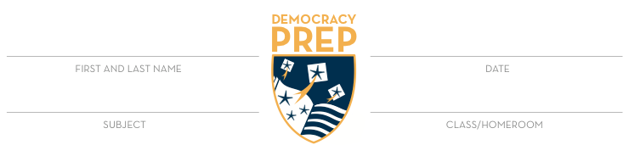

Presentation Observation Form
We will use this form to thoughtfully reflect on the presentations of others in order to improve our understanding of what strong presentations look like.

Positives To Look For:
- Talking instead of reading – using note cards and slides to begin, but not reading off them
- Knows the topic well – scholar is confident and gives details beyond the slides
- Eye contact with audience and appropriate volume for all to hear
- Well-designed slides (3-4 bullet fragments, organized images)
- Organized presentation that flows well between sub-topics

Name
Strengths of Presentation (2)
Constructive Feedback for Improvement

Name
Strengths of Presentation (2)
Constructive Feedback for Improvement
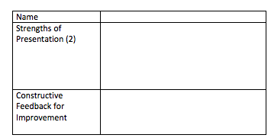

Name
Strengths of Presentation (2)
Constructive Feedback for Improvement

